**Problem # 4**

**Solution**

1. Start
2. Declare count =1 , number , L1=0 ,L2=0,L3=0
3. While count <= 10
   1. Input number
   2. If number > L1
      1. L3=L2
      2. L2=L1
      3. L1=number
   3. Else if number>L2
      1. L3=L2
      2. L2=number
   4. Else if number>L3
      1. L3=number
   5. Else
      1. Print next
   6. End if
   7. Count = count +1
4. End while
5. Print L1,L2,L3
6. End

**Flowchart**

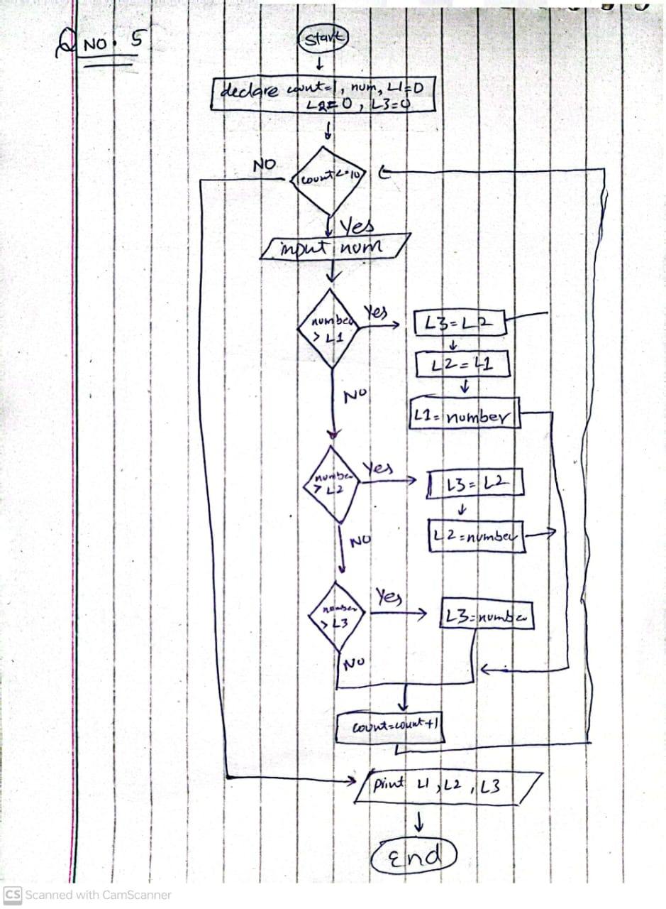

**Problem # 6**

**Solution**

1. Start
2. Declare binary , decimal=0 , base=1 , remain
3. Input binary
4. While binary != 0
   1. remain=binary%10
   2. decimal=decimal + remain*base
   3. binary=binary/10
   4. base=base*2
5. end while
6. print decimal
7. end

**Flowchart**

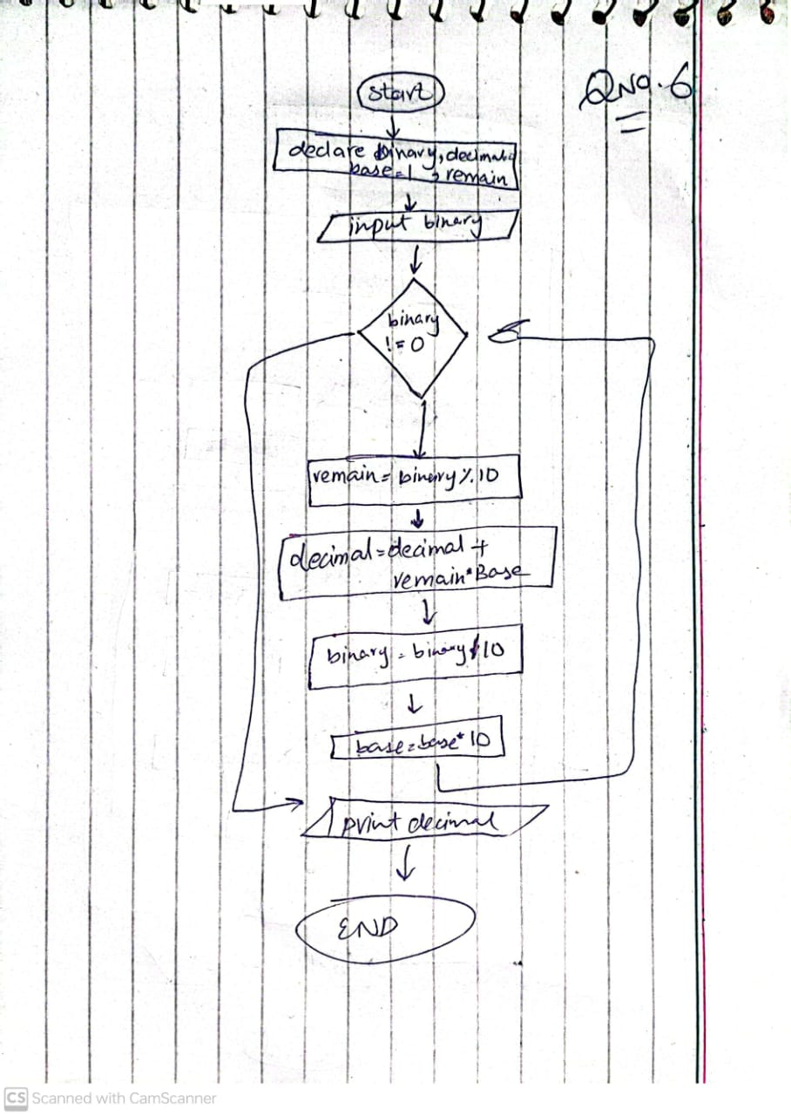

**Problem # 8**

**Solution**

1. Start
2. declare vowel, con, char
3. input char
4. while char != n
   1. if ( char == a || char== e || char==i|| char == o || char == u || char == A || char == E || char == I || char == O || char == U )
      1. vowel = vowel+1
   2. else
      1. con = con+1
   3. input n
5. end while
6. print con , vowel
7. end

**Flowchart**

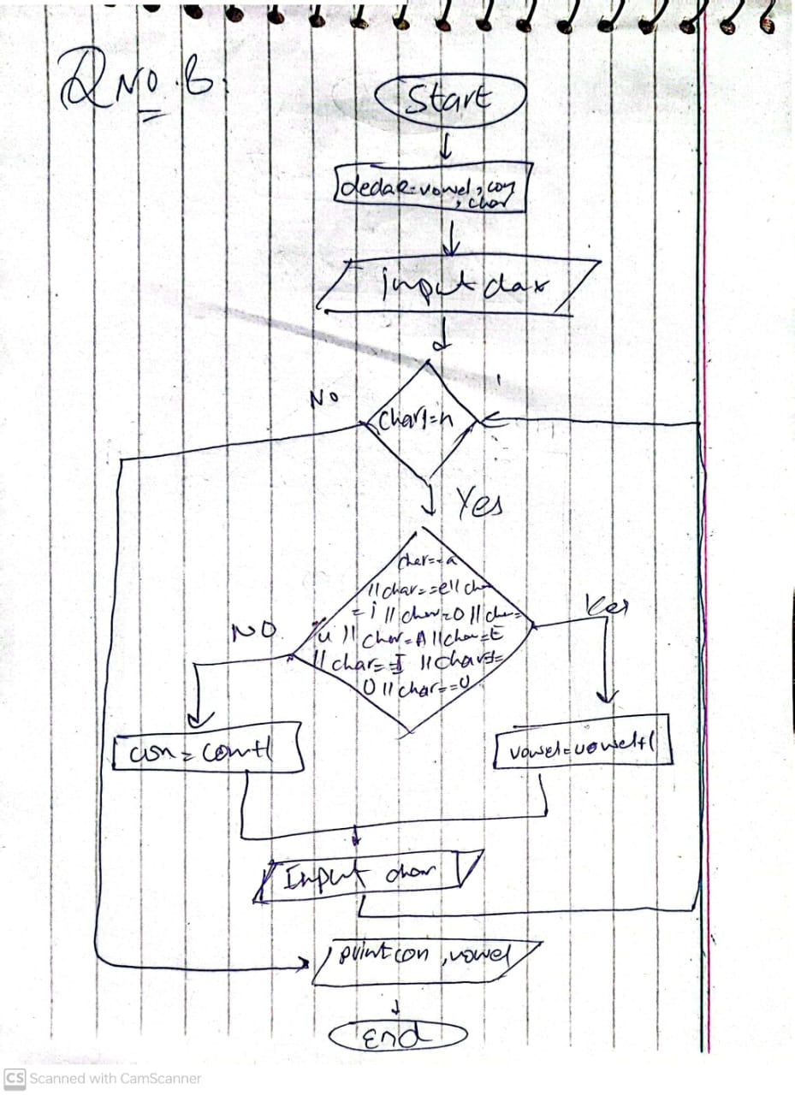

**Problem # 9**

**Solution**

1. start
2. declare day, month , year , c_day=1 , c_month=10 , c_year=2020 , ageMonth , ageyear , ageDays
3. input day , year , month
4. if ( month > c_month || month == c_month && day > c_day)
   1. ageyear=c_year – year -1
   2. agemonths=12-(month-c_month+1)
   3. agedays= c_days – days
5. else
   1. ageyears=c_year-year
   2. agemonth=c_month-month
   3. agedays = c_day – day
6. end if
7. print ageyear, agemonth , agedays
8. end

**Flowchart**

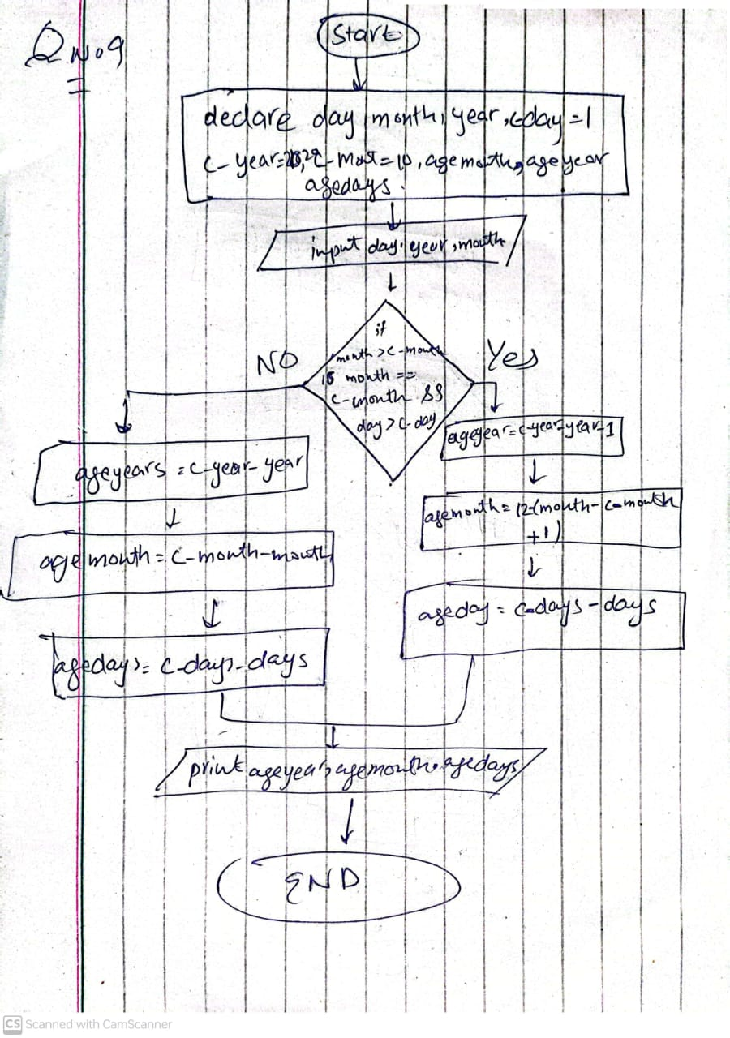

**Problem # 10**

**Solution**

1. start
2. declare factorial=1 , num , count =1
3. input num
4. while count <= num
   1. factorial = factorial * count
   2. count = count + 1
5. end while
6. print Fictorial
7. end

**Flowchart**

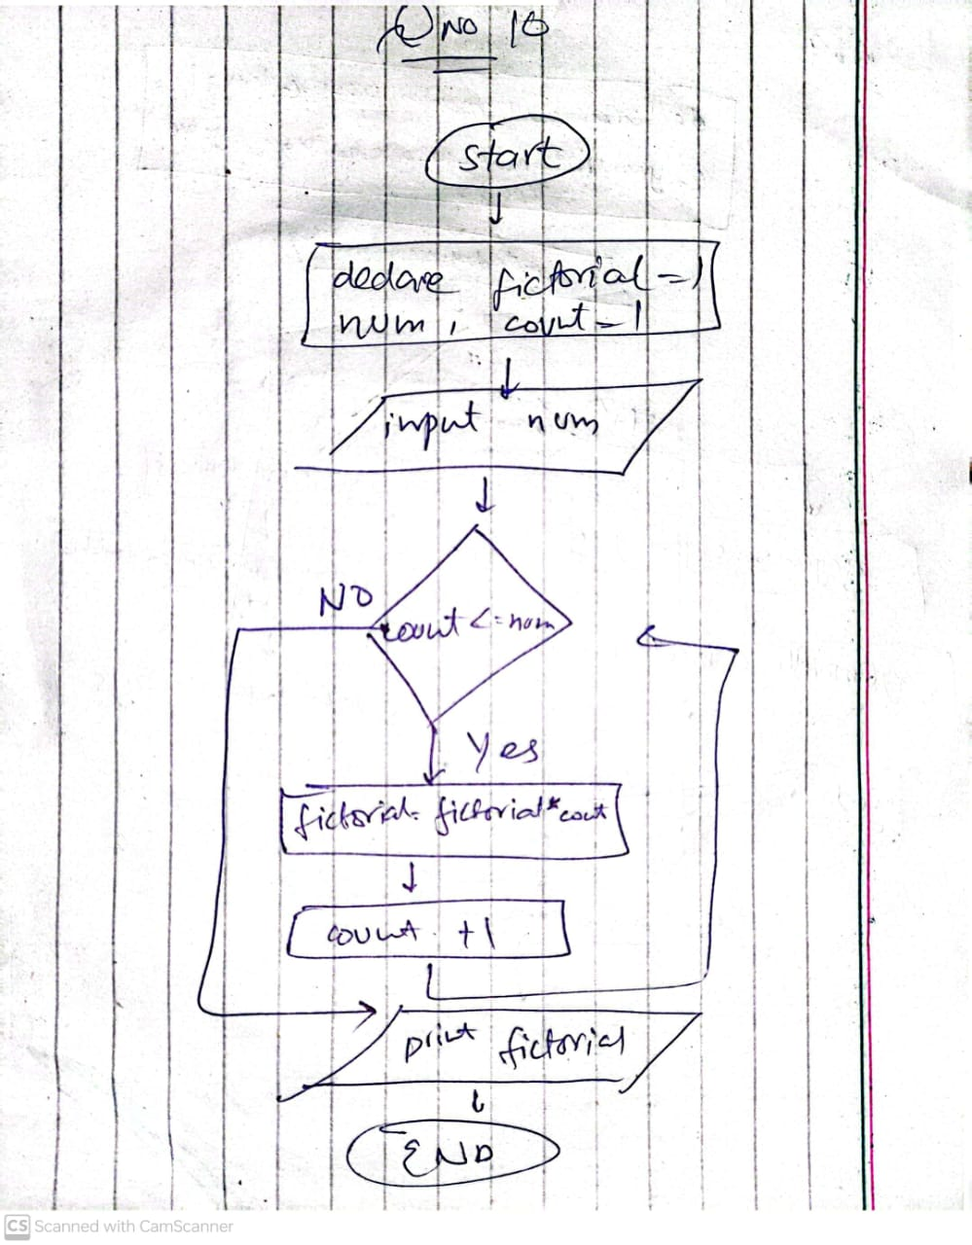

**Problem# 7**

**Solution**

1. start
2. declare num ,d1 ,d2 , d3 , d4 , encrypted
3. input num
4. d1= num/1000
5. d2=(num/100)%10
6. d3=(num/10)%10
7. d4=num%10
8. d1=(d1+7)%10
9. d2=(d2+7)%10
10. d3=(d3+7)%10
11. d4=(d4+7)%10
12. encrypted = d3*1000+d4*100+d1*10+d2
13. print encrypted
14. end

**Flowchart**

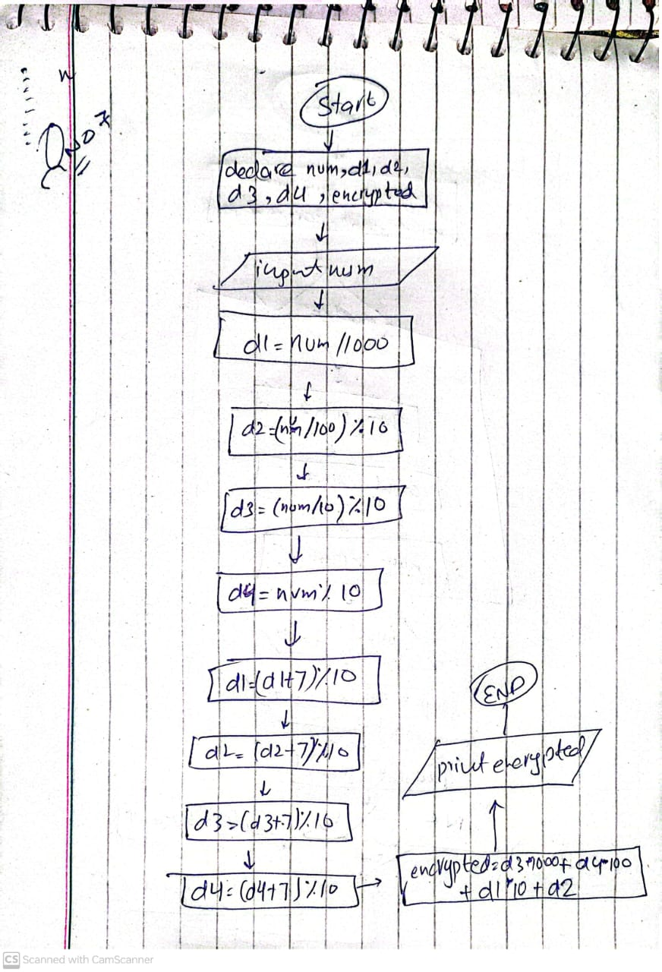

**Part 2:**

1. start
2. declare sum , num count , table , start , end , result
3. while count <= 15
   1. sum = sum + num
   2. num = num + 2
   3. count = count +1
4. end while
5. print sum
6. input table , start , end
7. count = start
8. while count <= end
   1. result = table * count
   2. print table , count , result
   3. count = count + 1
9. end while
10. end

**Flowchart**

